**Chapter 5 - Tissues, Organs, and Organ Systems**

**All Lectures Uploaded on YouTube:**

[**https://tinyurl.com/fkm9-biology**](https://tinyurl.com/fkm9-biology)

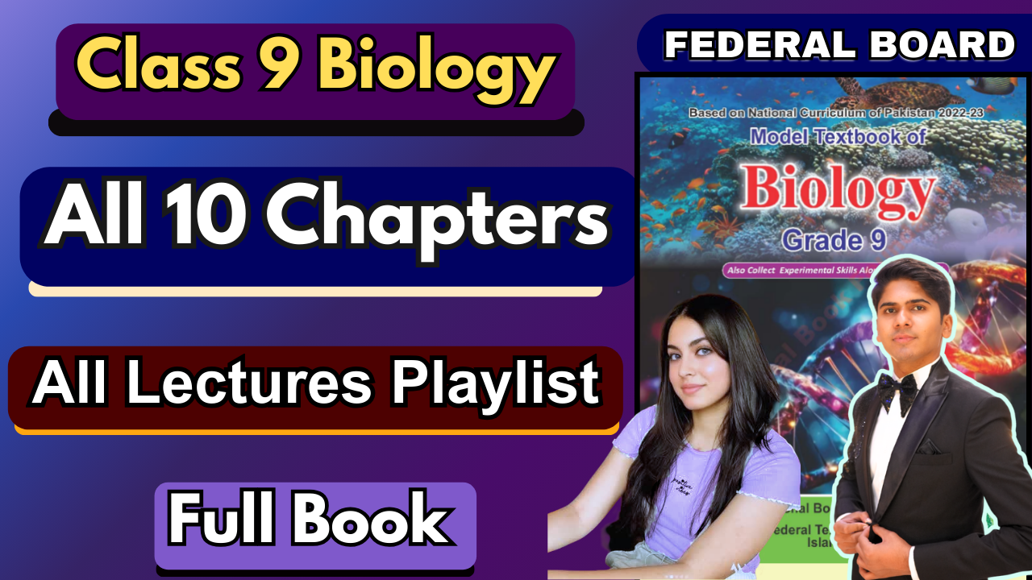

**Multiple Choice Questions:**

1. A
2. B
3. C
4. C
5. C
6. D
7. B
8. C
9. D
10. D
11. A
12. D
13. C
14. C
15. B

**Short Questions:**

1. Differentiate between:

* **Organ and Organelle**

**Organ**: A structure made up of different types of tissues that work together to perform a specific function. Examples include the heart, lungs, and stomach.

**Organelle**: Specialised structures within a cell that perform specific tasks. Examples include the nucleus, mitochondria, and ribosomes.

* **Animal and Plant Tissue**

**Animal Tissues**: Animal tissues are often more specialised and flexible, and they can be classified into four main types: epithelial, connective, muscle, and nervous tissues. Animal tissues are typically heterogeneous in their structure and function.

**Plant Tissues**: Plant tissues are mainly categorised into simple and complex tissues. Plant tissues tend to have rigid cell walls and are involved in processes like photosynthesis and transport. Examples include parenchyma, xylem, and phloem.

### **Xylem vs. Phloem**

**Xylem**: Tissue in vascular plants responsible for transporting water and minerals from the roots to the leaves. Xylem is made up of tracheids, vessels, and fibres, and it provides structural support to the plant.  
**Phloem**: Tissue responsible for transporting **food** (mainly sugars) from the leaves to other parts of the plant. It is composed of sieve tubes, companion cells, phloem fibres, and phloem parenchyma.

### **Epithelial vs. Muscular Tissue**

**Epithelial Tissue**: Tissue that forms the lining of body surfaces and cavities. It serves protective, absorptive, and secretory functions. It can be squamous, cuboidal, or columnar depending on the structure.  
**Muscular Tissue**: Tissue responsible for movement in the body. It is classified into three types: skeletal, smooth, and cardiac muscle. Muscular tissue contracts to produce force and movement.

### **Nervous vs. Connective Tissue**

**Nervous Tissue**: Composed of neurons and glial cells, nervous tissue is involved in transmitting electrical signals throughout the body. It is responsible for communication between different body parts and the brain.  
**Connective Tissue**: Tissue that supports and connects other tissues in the body. It includes a wide range of tissues such as bone, cartilage, blood, and adipose tissue. It provides structural and metabolic support.

### **Epidermal vs. Ground Tissue**

**Epidermal Tissue**: The outermost layer of cells in plants that protects against water loss, mechanical injury, and pathogen invasion. It often contains stomata for gas exchange and trichomes (hair-like structures) for protection.  
**Ground Tissue**: The tissue in plants that makes up the bulk of the plant's body. It includes parenchyma, collenchyma, and sclerenchyma tissues, which are involved in functions like photosynthesis, storage, and support.

### **Root vs. Shoot System**

**Root System**: The part of the plant responsible for anchoring the plant in the soil and absorbing water and nutrients. It consists of roots, root hairs, and root caps.  
**Shoot System**: The part of the plant that includes the stems, leaves, and flowers. It is involved in photosynthesis, reproduction, and the transport of water and nutrients between the roots and leaves.

### **Vegetative vs. Reproductive Part**

**Vegetative Part**: The non-reproductive parts of a plant, including the roots, stems, and leaves. These parts are responsible for the growth, support, and photosynthesis of the plant.  
**Reproductive Part**: The parts of the plant involved in reproduction, primarily the flowers and seeds. The flower contains the reproductive organs, and the seed helps in plant propagation.

1. The **stomach** is formed by several types of tissues that work together to perform its functions. The **epithelial tissue** lines the inner surface and secretes mucus to protect the stomach lining from acid. The **muscle tissue** (smooth muscle) forms the outer layers and contracts to churn food, mixing it with digestive enzymes and acids. **Connective tissue** provides structural support and connects the various layers, while **nervous tissue** controls the muscle contractions and the secretion of digestive juices.
2. The **respiratory** and **cardiovascular** systems work together to deliver oxygen to tissues and remove carbon dioxide from the body. The **respiratory system** brings oxygen into the lungs, where it diffuses into the blood. The **cardiovascular system** then transports oxygenated blood from the lungs to the heart and to all parts of the body. Similarly, carbon dioxide, a waste product of metabolism, is carried by the blood from tissues to the lungs to be exhaled.
3. The body regulates its temperature through a process called **thermoregulation**. The **hypothalamus** in the brain acts as the body’s thermostat. When the body temperature rises, the hypothalamus triggers mechanisms like **sweating** and **vasodilation** (widening of blood vessels) to release heat. When the body is cold, it triggers **shivering** and **vasoconstriction** (narrowing of blood vessels) to conserve heat. Additionally, behaviours like seeking shade or wearing warm clothes also help regulate body temperature.

**Extensive Answer Questions**

1. Structure and function of root hairs, xylem and red blood cells

**1. Root Hair Cells (Plants)**

**Structure**:  
- Long, thin extensions (root hairs) increase surface area.  
- Thin cell wall for easier diffusion.  
- Large central vacuole with low water potential.  
**Function**: Absorption of water and mineral ions from soil.

**2. Xylem Vessels**

**Structure:**

* Long, hollow, tube-like dead cells (no end walls).
* Lignified walls for strength and water resistance.

**Function**: Transport of water and minerals from roots to all parts of the plant.

1. Animal tissues are groups of specialized cells working together. There are four main types: **epithelial tissue**, which covers and protects surfaces and lines organs; **connective tissue**, which supports, binds, and connects body parts (examples include blood, bone, and cartilage); **muscular tissue**, which contracts to produce movement and includes skeletal, smooth, and cardiac types; and **nervous tissue**, which consists of neurons and is responsible for sending electrical signals to coordinate body functions. These tissues form the basic building blocks of organs and systems.
2. Living organisms are organised in levels, starting from the simplest. **Cells** are the basic unit of life. Groups of similar cells form **tissues**, which perform specific functions. Tissues combine to form **organs** like the heart or lungs. Multiple organs work together as an **organ system**, such as the digestive or circulatory system. All organ systems together make up a complete **organism**. This structured organisation allows life to function efficiently and adapt to various conditions.
3. Each human organ system has a specific role in maintaining life. The **circulatory system** transports oxygen, nutrients, and waste. The **respiratory system** handles breathing and gas exchange. The **digestive system** breaks down food and absorbs nutrients, while the **excretory system** removes waste. The **nervous** and **endocrine systems** control and coordinate body functions. The **muscular** and **skeletal** systems enable movement and provide support. The **immune** system defends against pathogens, and the **reproductive** system ensures continuation of the species. All systems work together to keep the body functioning properly.
4. Homeostasis is the body’s ability to maintain a stable internal environment. Different organ systems work together to achieve this balance. For instance, when blood sugar rises, the endocrine system releases insulin to lower it. During exercise, the muscular system uses more oxygen, so the respiratory and circulatory systems work faster to deliver oxygen and remove carbon dioxide. If body temperature rises, the nervous system triggers the skin to release sweat. These interactions ensure that internal conditions such as temperature, water balance, and pH remain within normal limits.
5. The leaf is adapted to carry out photosynthesis efficiently. The upper layer contains palisade mesophyll cells packed with chloroplasts to capture sunlight. Below them, spongy mesophyll cells have air spaces to allow gases like CO₂ and O₂ to diffuse easily. Stomata, mainly on the lower surface, regulate gas exchange and water loss, controlled by guard cells. Xylem vessels bring water to the leaf, while phloem transports the sugars made during photosynthesis. These structural adaptations ensure that each part of the leaf contributes effectively to its function.

